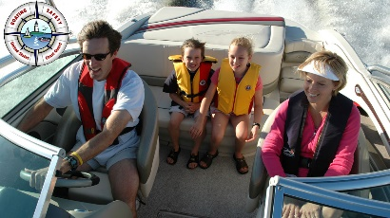
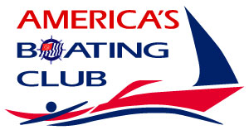
Great Blue Hill Sail
and Power Squadron

BOAT HANDLING COURSE AND SEMINAR SERIES
Increase your competence, build your confidence, and have more fun on the water!
For both sail and power boaters, take the classes that are important to you.

BOAT HANDLING COURSE- USPS Members can take any of the following for $25 each. Earn your Seamanship (S) rating by taking all 6 classes and passing the exam on Monday 4/20. Register for all 6 for only $99! Non-member prices are $35 per night or $149 for the 6 nights. In Person classes are at the Westwood Council on Aging, 60 Nahatan Street, Westwood, MA.

Registration CLICK HERE:
OR cut and paste this URL into your web browser https://buytickets.at/greatbluehillsailandpowersquadron/830508

Mon. Mar 06 – 7 to 9 pm, Rules of the Road- Avoid collisions and other hazards! Know the rules of the road; know what to do when you share the water with other boats. Instructor: Capt. Jeff Gardner

Mon. Mar 13 - 7 to 9 pm, Docking with confidence- Docking can be one of the most stressful tasks you can perform. Look like a pro. Protect your boat, your passengers, and yourself with the docking/undocking skills you need. Instructor: Dave Albanese
Mon. Mar 20 - 7 to 9 pm, Boating with Confidence- Gain confidence, knowledge, and skills that you need for a variety of boat-handling situations. Learn about basic operations; trimming your boat; operating on plane; handling seas and waves; dealing with bars, rivers, rivers, and bends; and other situations you will encounter along your cruise. Instructor: Capt. Jeff Gardiner
Mon. Mar 27 - 7 to 9 pm, Anchoring- Whether it's for fishing, swimming, a lunch break, or an overnight stop, one of the real pleasures in boating is "hanging on the hook" in some quiet spot. Know how to anchor in a variety of situations, weather, or seabed and be prepared to adjust for changing conditions. Instructor: Joe Kelliher
Mon. Apr 3 - 7 to 9 pm, Emergencies on Board- No one wants to think about it, but emergencies happen on boats. Be prepared for a variety of boating mishaps, medical emergencies, and other crises! Instructor: Laurie Reilly, RN
Mon. Apr 10 - 7 to 9 pm, Knots and Line Handling- Learn how to secure your boat to docks, piers, and other boats; handle rescue and repair situations; manage running rigging; anchor securely; and tow other vessels or people. Full 6 session exam at end of class. Instructor: Joe Kelliher
We look forward to seeing you all at the seminars! Feel free to invite your friends and family.

If you have any questions please feel free to call me at 781-248-5759 or by email at james.andersenjr@protonmail.com

Fair winds and following seas, Jim Andersen N, XO

